Capstone Task Day 01
Tasks:
open terminal in raspi OS then :
1.sudo apt update && upgrade
2.echo "Kernel: $(uname -r) | user: $(whoami) | date: $(date) "
3.mkdir iot_logger
4.cd iot_logger/
5.mkdir logs scripts data
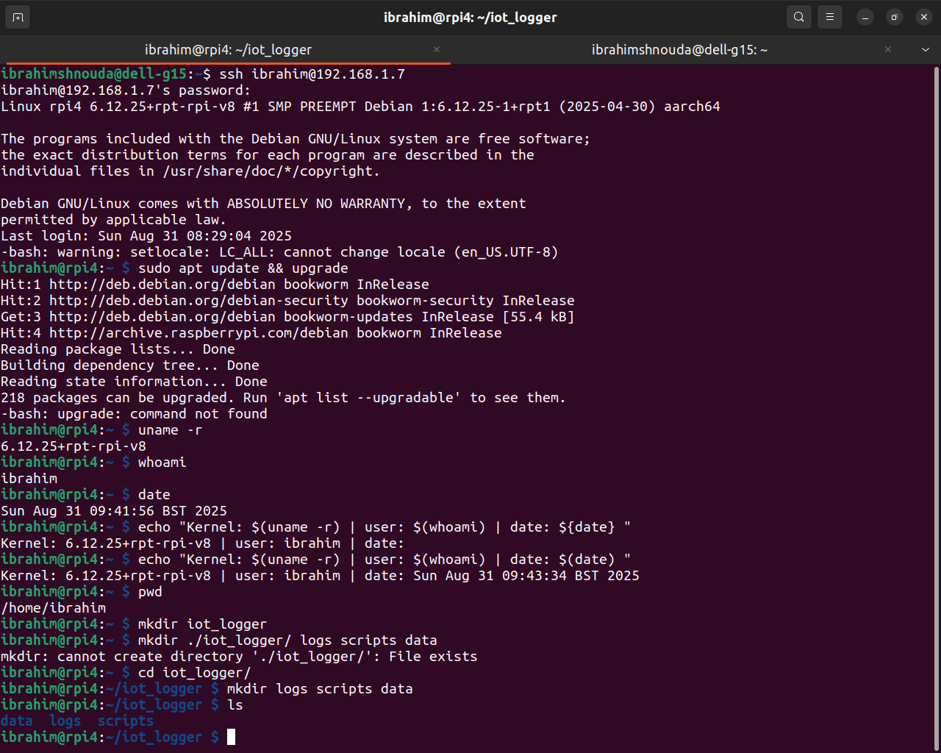

Open-Ended Questions:

1. Linux Architecture

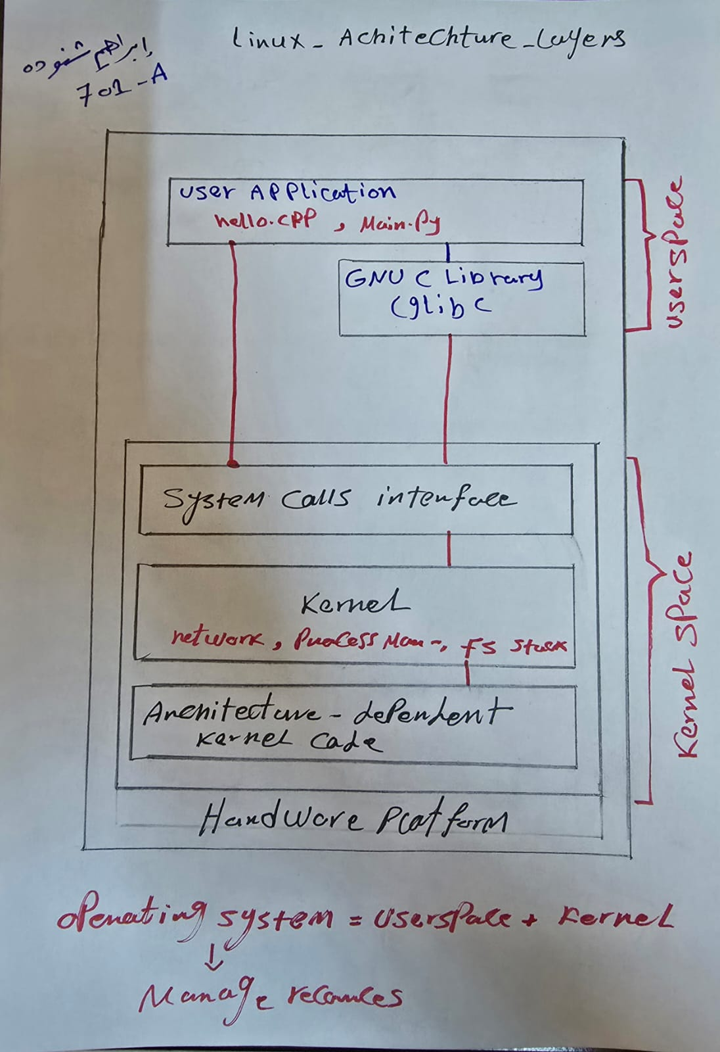

some definitions:
1.Kernel: kernel simply is the Software can manage Hardware direct
2.Hardware: is the platform or the machine can run S/W Programs
3.User space: applications run in the upper layer of OS can not access H/W direct
4.System calls: S/W play the role between user space apps and kernel to ask kernel to run this app
5.shell: is a user space app

2.the purpose of these directories:
2.1. /: root directory is the upper layer of linux file system, that all directories
starts from the root directory.

2.2. /bin: binary contains the essential user command for operational use like: cd, ls , cat, mkdir

2.3./sbin: similar to /bin but contains system administration command, mostly used by root file system like: shudown, ifconfig, fdisk

2.4./usr: contains the most installed applications , librares and documents like /bin/lib

2.5./etc: contains the system configurations files like /etc/passwd : usr account info

2.6./var: contains the variables data that changes while the system running like /var/log

3.Every thing is a File , Process vs Program

3.1.in linux you can treat with any file by open(), read(), write(), close() system calls because it SIMPLE AND UNIFORM.

3.2. Program is the instructions code in the hard disk, but process the the running of this program in memory and program can create many
and process can be multiple of threads, thread is execution inside process

